# **SAVING A CANADIAN ICON**

**“BlackBerry LTD”**

# **Leadership Development**

# **Plan and Strategy**

**Group 3**

|  |  |
| --- | --- |
| **Maninder Kaur Baria** | **A00429943** |
| **Caner Irfanoglu Adil** | **A00425840** |
| **Aman Sharma** | **A00429273** |
| **AbdelRahman Hassan** | **A00419918** |



Contents

SAVING A CANADIAN ICON 1

Leadership Development 1

Plan and Strategy 1

Executive Summary 3

Strategy Statement 3

SWOT Analysis 3

Preliminary Analysis 3

Strategy Plan of Action 4

Anticipate Obstacles 5

Who can support BlackBerry? 5

Establishment plan requirements 5

How can BlackBerry evaluate their progress? 5

Conclusion 6

# Executive Summary

Blackberry, which was the pioneer in mobile-based technologies with its bestselling original Smartphones, has been in the news for all the wrong reasons. First, the company known as Research in Motion (RIM), which made and marketed the Blackberries, missed the emerging Smartphone revolution though it was one of the pioneers of mobile computing.

Next, the company was unable to read the market and hence, it lost market share to Apple and Samsung. This resulted in the company nearly going bankrupt and despite changes in leadership; they didn’t regain back their position.

This report discusses the strategies for Blackberry, which would provide clues into how the company could position itself in the future.

The key theme here is that Blackberry needs to urgently revamp and rejuvenate itself if it has to regain market share and forget about market leadership, it has to ensure that it stays afloat for now.

# Strategy Statement

Become a key player providing network and software security solutions and certifications for IoT devices across multiple platforms and brands, thus becoming the gold standard in providing consumers satisfaction in security and privacy.

This will be achieved by providing security solutions that leverage Blackberry’s reputation, expertise and contracts which the consumers can trust when purchasing IoT devices.

The benefit will be to become the most trusted brand in software security solutions, providing stability and promoting growth of the corporation.

# SWOT Analysis

We will first perform SWOT analysis to determine our strengths, weakness, Opportunities and Threats. Based on this we can determine how to perform differently/better that would make the greatest positive impact to BlackBerry?

|  |  |
| --- | --- |
| **Strengths**  BlackBerry is very competitive in security, has a formidable leadership team, improving financials and some strong assets thoughtfully acquired, which in turn of opening new white space for it to attack.  One of the main strengths of Blackberry is that its devices are more secure than its competitors and indeed, the security features inherent and embedded in the devices are unmatched by any other mobile maker including Samsung and Apple. This is the reason why Blackberries are so popular with corporate users who use it to link it and integrate it with their VPNs or Virtual Private Networks. | **Weakness**  BlackBerry must decide what it does with its global network. The company can’t afford the drain on resources if the network isn’t enhancing the value of its software assets or opening new market opportunities.  The key weakness that Blackberry has is that it went on a single-track focus on the corporate users and enhanced its security features as a USP or a Unique Selling Proposition. While this aspect held it in good stead as far as the corporate clients are concerned, once Samsung and Apple came out with Smartphones for the consumers and the everyday usage, Blackberry was unable to keep up with the competition. Indeed, both Samsung and Apple have cornered the market share by enhancing the security features in their Smartphones. |
| **Opportunities**  BlackBerry should focus integration efforts on the intersection of its IoT and business productivity strategies, around which significant synergies will exist in customer requirements for management, productivity and security. It would also be wise to help grow partner ecosystems around its licensing partners in emerging markets to catch the uptick in demand for value-added business productivity services. And it should build relationships with IoT OT players and strategize its future in non-smartphone hardware categories.  By integrating the third-party apps and features into its phones, the company can mimic the strategies followed by Apple and Samsung and the increase in the business partnerships with third party providers can prove to be a key opportunity for the company as it prepares to take on Samsung and Apple. | **Threats**  Though Blackberries were the original Smartphones, both Apple and Samsung beat it to the race to build the Smartphone of the future because they provided the flexibility and ease of use that Blackberries lacked and hence, were able to corner market share and take away its competitors.  Apart from the threats posed by its competitors, Blackberry has to fight the slack and the gloomy internal environment, which because of the troubles that the company has been through in recent years has resulted in lower employee morale and a general lack of direction. Given the fact that the Smartphone industry thrives on innovation, Blackberry must rejuvenate itself and reinvent itself apart from rescuing itself from the sagging momentum and motivation of its employees. |

# Preliminary Analysis

1. **Understand first things first**. It’s necessary to maneuver current product inventory, however at the same time create long-run development a priority. Blackberry suffered from bad decision-making. Blackberry failed to strategically plan and implement good management strategies for a successful turnaround.

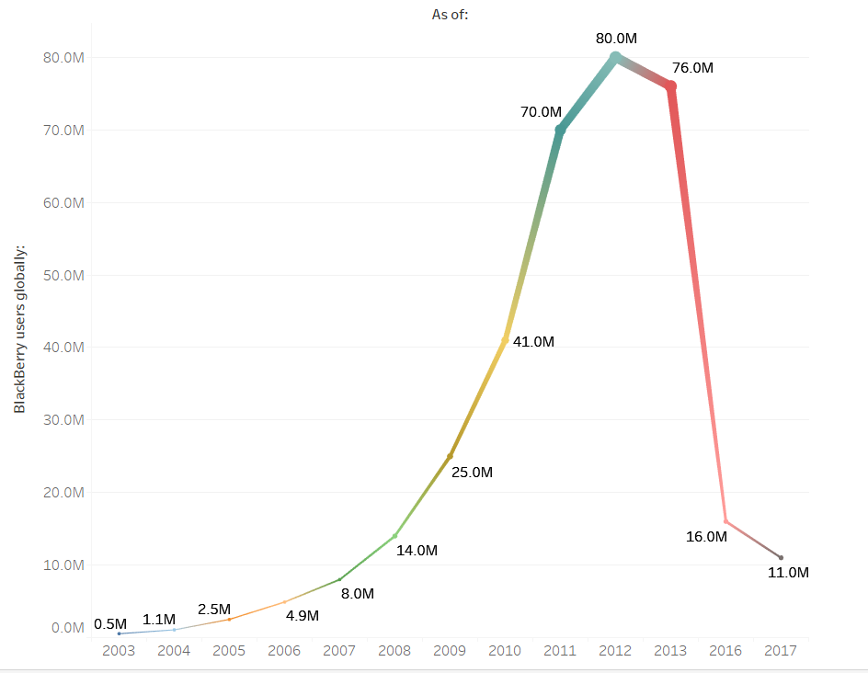

**Data Source:** <https://en.wikipedia.org/wiki/BlackBerry>

1. **Develop a strategic promotion and align it with sales**. Obviously, Blackberry also failed in marketing. That included the necessary basics for marketing plan results, and for profits, it’s critical to align marketing with sales.
2. **Attract visionary product-creation relationships**. Blackberry lost ground as a result of it didn’t have enough developer support, which opened the door for competitors. It’s important to stay atop marketplace volatility. Hire or partner with visionary innovators. Blackberry didn’t do enough vetting forming a partnership and strategic alliances.
3. **Create an iconic product.** In Blackberry’s case, it missed opportunities to create excitement by intensifying its research and development for a blockbuster smartphone – bigger screen, 4G, and better camera. Its new product line was two years too late. Innovation is key to be a top innovator.
4. **Restructure the team.** Mr. Heins errantly believed drastic change isn’t necessary — he needed to wake up quickly and reverse course. He should have made certain he employed a lot of thought leaders to serve as devils’ advocates. But again, he’s lost top executives. Blackberry has to earn marketplace confidence by exploring and act all its strategic choices.
5. **Operate profitably**. A laser focus on profitability is warranted. It starts with understanding what drives profit. Being a leader in profit is necessary.
6. **Continue to focus and promote security**. Daily, the media is stuffed with headlines concerning fraud and security. Blackberry is thought for its security; however, the message has been diluted.
7. **Manage your reputation.** The key is to create positive images. But Blackberry is suffering in reputation management. The company needs to optimize its brand to manage its reputation. That means leveraging the news media for good publicity. Further, when a company such as Blackberry has a PR crisis, it’s time to implement PR crisis management tips.

# Strategy Plan of Action

The strategy plan of action has been developed through primary analysis and SWOT analysis. The goals devised here discusses approach that can help the company become a stable player in the market, thereby securing its future for the foreseeable future unlike the collapse towards the end of the previous decade.

The following are the goals in the plan:

**Goal 1: Main Initiatives, BlackBerry Core Values and Product Modelling**

1. Software, Compatibility and Virtualization
2. Pursue and expand with new streamlines of technologies that include but not limited Telecommunication, Vehicles QNX and Aircraft systems.
3. Autonomous Software and BlackBerry QNX
4. Cloud Services, Data Synchronization and BBM Applications
5. Enterprise Software, Services, and the Internet of Things
6. Advanced Security and Privacy

**Goal 2: Marketing Strategy**

1. Unique BBM Taste and Design
2. Re-design 90s & 2000’s Models and Target Different Generations
3. Incentive and Loyalty Programs
4. Smart Phones, Smart Watches, Tablets and Foldable Devices
5. Buy-Back Program, Blackberry Expo Training & investing on Key Note events.

**Goal 3: Continue building connections and expand technological horizons**

1. Attract more entertainment focused consumers instead of relying solely on business segment by increasing its advertising.
2. Full speed ahead in driverless cars
3. “The internet of things” – Everyday objects with connectivity
4. Form strategic alliances with other player in industry.
5. Help to Expand NantHealth to global level.

# Anticipated Obstacles

**What barriers can we identify which might hinder us in pursuing our development goals? How can we overcome these barriers?**

|  |  |
| --- | --- |
| **Obstacle/Barrier** | **Solution** |
| 1. Strong competition in the market from Samsung Apple, Huawei and other competitors. | * Providing at least same technologies and features used by these companies and exceed with expectation of design, technology and cost. * Provide affordable devices to accommodate and attract more target audience. * Support Loyalty Programs for BlackBerry users and provide wide range of bundling options. |
| 2. BlackBerry Operating System Compatibility with Android and other operating systems. | * Develop strong Virtualization and Emulation Platforms to run on BlackBerry to make devices widely compatible. * Keep specific models running Android version as of the existing devices available to eliminate any risk of losing track if fully switched back to BlackBerry O/S. |
| 3. Lack of support of BlackBerry developers, technical support and open forums services. | * BBM Community Club, Online Training Courses and Forums * Graduate Programs * Hackathons |

# Who can support BlackBerry?

Our users, Government of Canada, Canadian companies and manufacturing industries to help us as Canadian value and reputable company worldwide.

Recently Ottawa is invested $40 million into BlackBerry's QNX division, which is based in the Ottawa suburb of Kanata, to help the company develop automated control systems, and improve vehicle safety and security by expanding its driver assistance system.

# Establishment plan requirements

1. Planning and Initiation
2. Prioritization and Execution
3. Parallel Modeling Branding (Product Modelling Categorization)
4. Monitor, track and execute plans precisely with the help of strong leadership.
5. Risk Management Process and Risk Evaluation
6. Cut unnecessary costs by reducing resources with Automation.
7. Providing different kind of products in the Market

# How can BlackBerry evaluate their progress?

1. Look at Their Financial Statements.
2. Check Customer Satisfaction.
3. Average How Many New Customers You Get.
4. Conduct Performance Reviews.
5. Stay Current on The Market.
6. Assess Their Own Expectations.

# Conclusion

To conclude, the effectiveness of the strategy and the trust put in this plan comes from the leaders Blackberry has today, as well as it being in line with current company-wide strategies that already exist.

This ensures that the strategy is not too radical, which requires a complete shift and a lot of investment from a company that is already on the brink. The highlighted strategies mainly have to do with rebranding, and meeting with today’s demand.